MODERN WELDING SCHOOL

CAMPUS SECURITY
AND
FIRE SAFETY REPORT

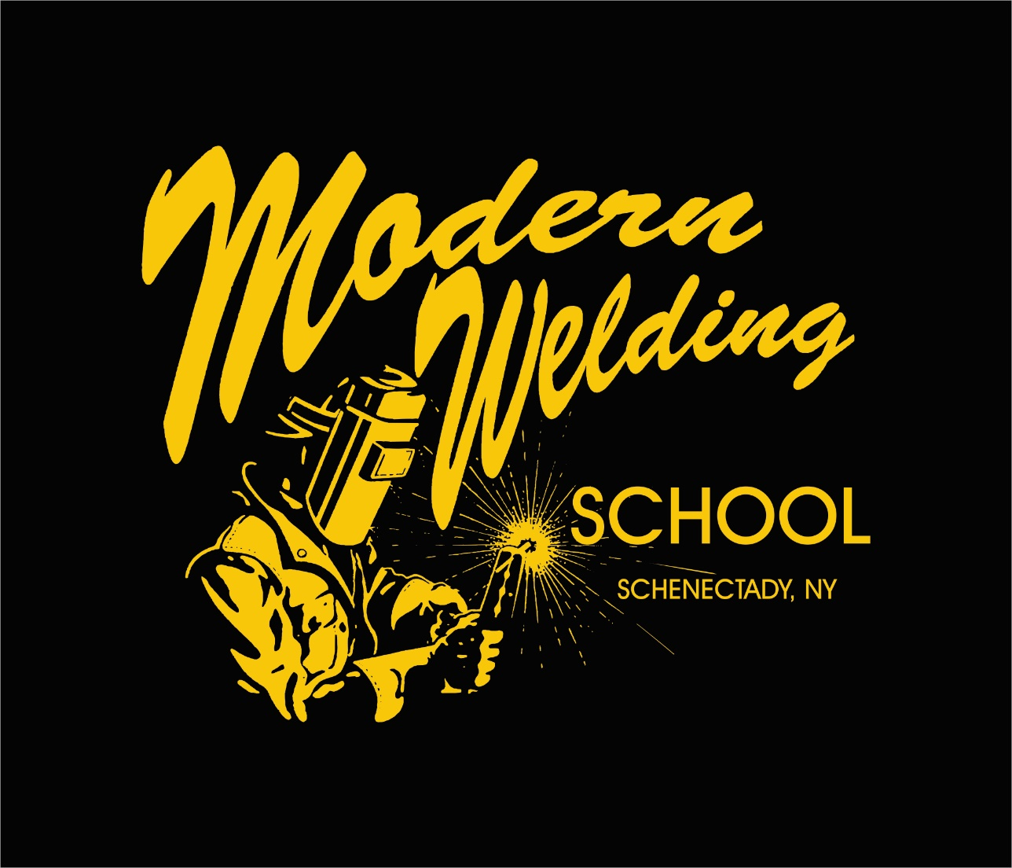

Modern Welding School
1842 State Street
Schenectady, NY 12304
518 374 1216
Security Report
Safety at Modern Welding School (MWS)
Safety at MWS is the responsibility of students, faculty and staff. The safety of all depends on the each member taking the responsibility of keeping themselves and others safe seriously.
To help protect each other and your belongings all individuals need to think about safety and security on campus utilizing the suggestions and resources identified in this report. Everyone has a responsibility in reporting all campus crimes and safety concerns to the appropriate authorities. All of us working together will help ensure the safety of all employees and staff at MWS.
Campus Facility
MWS is located at 1842 State Street Schenectady, NY 12304. Schenectady is a busy city which has a population of approximately 69,500 residents and is located a few miles from the Capital of New York, Albany. MWS is located in a commercial and residential location. The school is accessible by foot and is also a main stop on local CDTA bus routes.
MWS’S administrative office is located in the front of the building and is accessible between the hours of 7:00 am and 4:30 pm Monday thru Thursday. The teaching facility is located in the rear of the building and is accessible from Monday 9:00 am to 4:30 pm and Tuesday-Thursday 8:00 am thru 4:30 pm. The evening students begin class at 5:30 pm and end class at 9:30 pm Monday thru Wed and 8:30 pm on Thursday.
All visitors must report to the administrative office prior to entering the facility.
Deliveries can be made at several locations on the premises but must have faculty assistance.
MWS does not have any off campus facilities and does not provide law enforcement services to off-campus activities on behalf of MWS.
Personal Safety Recommendations
MWS suggests that every student, employee and visitor take responsibility for their own security and the security of others. All new enrolled students participate in a general orientation class. During the orientation class, the need and procedure of reporting emergencies and criminal activities, campus security measures and crime prevention is discussed. Similar information is presented to new employees. In addition, information is disseminated to students and employees through tips posted in MWS buildings, in-class announcements, and announcements through social media.
*Firearms/weapons of any kind are prohibited on campus. This includes concealed weapons even if the carrier has a permit.
*Dial 911 for all emergency assistance.
*Drugs and Alcohol are prohibited on campus.
Campus Security Offices and Local Law Enforcement
MWS’s administration attempts to provide a safe, secure educational environment for all students and employees. MWS does not provide security guards on its campus premises. The ultimate authority for law enforcement at MWS is the local police department. MWS does not have any written agreements with local police departments for the investigation of alleged criminal offenses. MWS officials have the authority to contact the local police to request assistance in preventing or reacting to crime within or in the immediate vicinity of school facilities.
The Director of Education at MWS is also our Campus Security Officer. He is responsible for all dealings with local law enforcement. The school works with the local law enforcement yearly to review reports which shows any crimes within the immediate areas. In the event of all emergencies any party involved should call 911 immediately.
EMERGENCY PROCEDURES
Emergency Threat
MWS, as with any school, is not immune from the possibility of someone posing a threat of harm to themselves or others. Remember that safety is a shared responsibility so everyone is strongly encouraged to notify staff at MWS of any threat made to harm individual or property at the school. Any staff member made aware of the situation should immediately report it to the campus security officer. It is his responsibility to review and address the situation.
Emergency Response
When a threat is reported our staff attempts to validate the report and collects all information. If assistance is needed, local law enforcement, fire dept, or emergency medical assistance is called. Our staff will work to contain the situation. Once emergency responders arrive they are in control of the situation.
Emergency Notification
If a situation arises that urgently threatens the safety and concerns of the individuals of MWS an announcement will be made over the loudspeaker. The exception to this would be if the announcement causes greater concern to staff and students.
Evacuation Information
Depending of the emergency evacuation may be needed. Evacuation procedures are posted in the classroom and are attached to this report.
Reporting Campus Crime
MWS students, employees, and visitors are encouraged to report quickly and accurately all campus crimes and incidents related to public safety to their instructor or the Campus Security Officer. Due to the importance of campus safety, MWS cannot guarantee that crime information will remain confidential.
Emergency Contact Information
Emergency Assistance: 911
Emergency Security: 518-374-1216

Alcoholic Beverages or Controlled Substances
It is the policy of the Modern Welding School that the unlawful manufacture, distribution, dispensation, possession, or use of a controlled substance or alcohol is prohibited while in the workplace, on MWS premises, or as part of any MWS sponsored activities. Any employee or student violating this policy will be subject to disciplinary action up to and including termination or expulsion and referral for prosecution. The specifics of this policy can be found in the Drug Free School Policy.

Alcohol and Substance Abuse Education
MWS has developed a program to prevent the illicit use of drugs and the abuse of alcohol by students and employees. The program provides services related to drug use and abuse including dissemination of information materials, referrals, and MWS disciplinary actions.
A violation of any law regarding drugs or alcohol is also a violation of MWS’s Drug Free School Policy and will be treated as a separate disciplinary matter by MWS.
Local mental health and substance abuse services are available at:
Carver Community Counseling: 846 State St. Schenectady, NY 12307 (518) 382-7838
New Choices Recovery: 302 State St. Schenectady, NY 12305 (518) 346-4436
Conifer Park: 79 Glenridge Road Glenville, NY 12302 1-800-989-6446

Additional information about drug and alcohol abuse, health risks, addiction and prevention can be accessed at the National Academy on Alcohol Abuse and Alcoholism (www.collegedrinkingprevention.gov) as well as the National Academy on Drug Abuse (www.drugabuse.gov/DrugPages/DrugsofAbuse.html).

Sexual Misconduct Policies & Procedures
Modern Welding School is committed to providing a working and educational environment for all students, faculty and staff that is free from sex discrimination, including sexual misconduct. Sexual misconduct includes sexual assault, sexual harassment and exploitation, domestic violence, dating violence and stalking. Every member of the school community should be aware that MWS is strongly opposed to sexual misconduct, and that such behavior is prohibited by state and federal laws.
MWS’s Sexual Misconduct Policy describes MWS’s programs to prevent sexual misconduct, and the procedures that MWS will follow once an incident of sexual misconduct has been reported. This Policy is disseminated to the MWS community through publications, the MWS website, new employee orientations, student orientations, and other appropriate channels of communication. Copies of the Policy can be obtained from the Director of Education in-person or by calling (518) 374-1216, or downloading from MWS’s website at www.modernwelding.com. MWS provides training to key staff members to enable MWS to handle any allegations of sexual misconduct promptly and effectively. MWS will respond quickly to all reports of sexual harassment, and will take appropriate action to prevent, to correct, and if necessary, to discipline behavior that violates this policy.
MWS’s Sexual Misconduct Policy governs sexual misconduct involving students that occurs on any MWS property or in connection with any MWS-sponsored program or event. This Policy applies to all students, employees, and third parties conducting business with MWS, regardless of the person’s gender, gender identity, sexual orientation, age, race, nationality, class status, ability, religion or other protected status. MWS encourages victims of sexual violence to talk to somebody about what happened – so victims can get the support they need, and so MWS can respond appropriately. As further described in the Policy, MWS will seek to respect a victim’s request for confidentiality to the extent possible, while remaining ever mindful of the victim’s well-being.
Counseling, advocacy and support services are available for victims of sexual misconduct, whether or not a victim chooses to make an official report or participate in MWS’s disciplinary or criminal process. Personal counseling offered by MWS will be limited to initial crisis assessment and referral.
Sexual misconduct crisis and counseling options are available locally and nationally through a number of agencies. Contact information for these agencies is included in MWS’s Sexual Misconduct Policies and Procedures

Sexual Offender Registration
In accordance to the Campus Sex Crimes Prevention Act of 2000, the Clery Act, and the Family Rights and Privacy Act of 1974, MWS is providing information for where students and employees may obtain information regarding registered sex offenders. The New York Sex Offenders Registry may be found at:
http://www.criminaljustice.ny.gov/nsor/
The Campus Sex Crimes Prevention Act requires institutions of higher education to provide a statement advising the campus community where law enforcement information provided by a state concerning registered sex offenders can be obtained.

CRIME STATISTICS
Campus crime, arrest, and referral statistics include those reported to the Director of Education and local law enforcement agencies. Copies of the report may be obtained from the Director of Education or by calling (518) 374-1216. All prospective employees may obtain a copy from the Director of Education or by calling (518) 374-1216.
To Report A Crime
Contact the Director of Education at (518) 374-1216 (non-emergencies) or dial 9-1-1 (emergencies only). Any suspicious activity or person seen loitering inside or around MWS buildings should be reported to the Director of Education.

Campus Crime Statistics
Offense | On Campus |  |  | Non Campus |  |  | Public Property
 | 2020 | 2021 | 2022 | 2020 | 2021 | 2022 | 2020 | 2021 | 2022
Murder/Non-Negligent Manslaughter | 0 | 0 | 0 | 0 | 0 | 0 | 0 | 0 | 0
Negligent Manslaughter | 0 | 0 | 0 | 0 | 0 | 0 | 0 | 0 | 0
Sex Offenses – Forcible | 0 | 0 | 0 | 0 | 0 | 0 | 0 | 0 | 0
Sex Offenses - Non-Forcible | 0 | 0 | 0 | 0 | 0 | 0 | 0 | 0 | 0
Robbery | 0 | 0 | 0 | 0 | 0 | 0 | 0 | 0 | 0
Aggravated Assault | 0 | 0 | 0 | 0 | 0 | 0 | 0 | 0 | 0
Burglary | 0 | 0 | 0 | 0 | 0 | 0 | 0 | 0 | 0
Motor Vehicle Theft | 0 | 0 | 0 | 0 | 0 | 0 | 0 | 0 | 0
Arson | 0 | 0 | 0 | 0 | 0 | 0 | 0 | 0 | 0
Domestic Violence | 0 | 0 | 0 | 0 | 0 | 0 | 0 | 0 | 0
Dating Violence | 0 | 0 | 0 | 0 | 0 | 0 | 0 | 0 | 0
Stalking | 0 | 0 | 0 | 0 | 0 | 0 | 0 | 0 | 0
Liquor Law Arrests | 0 | 0 | 0 | 0 | 0 | 0 | 0 | 0 | 0
Liquor Law Violations Referred for Disciplinary Action | 0 | 0 | 0 | 0 | 0 | 0 | 0 | 0 | 0
Drug Law Arrests | 0 | 0 | 0 | 0 | 0 | 0 | 0 | 0 | 0
Drug Law Arrests Referred for Disciplinary Action | 0 | 0 | 0 | 0 | 0 | 0 | 0 | 0 | 0
Illegal Weapons Possession Arrests | 0 | 0 | 0 | 0 | 0 | 0 | 0 | 0 | 0
Illegal Weapons Possession Violations Referred for Disciplinary Action | 0 | 0 | 0 | 0 | 0 | 0 | 0 | 0 | 0
Unfunded Crimes | 0 | 0 | 0 | 0 | 0 | 0 | 0 | 1 | 0
Crime statistics for domestic violence, dating violence and stalking were added effective 2013.
To research crime statistics please go to the following website: http://ope.ed.gov/campussafety/#/institution/search
MODERN WELDING SCHOOL
DRUG FREE SCHOOL POLICY
Modern Welding School believes that it is very important to provide a safe environment for all of its students and staff. Substance abuse, while at work, school or otherwise, seriously endangers the safety of students and staff, as well as the general public, and creates a variety of problems including increased theft, decreased morale, decreased productivity, and a decline in the quality of services provided. It is also our Policy to prevent the use and/or presence of these substances in the school. MWS will strive to provide an environment conducive to making conscientious and healthy decisions when students are faced with difficult choices associated with the use of legal and illegal drugs.
It is a violation of school policy for any student to:
- Use illegal drugs or misuse prescription drugs;
- Misuse alcohol;
- Possess, trade, manufacture, distribute, dispense, buy or offer for sale alcohol, illegal and/or prescription drugs while on duty, during break periods, or on school property;
- Arrive or return to school intoxicated from use of illegal drugs, misused prescription drugs or alcohol;
- Engage in the use of illegal drugs, misuse of prescription drugs or alcohol during school hours or while on school property (including parking lots);
- Use prescription drugs or non-prescription drugs that may affect the safety of the student or fellow students, and members of the public;
- Have tampered or attempted to alter or attempt to interfere with the testing procedure; or
- Otherwise has refused to be tested.
For the purpose of this Policy, a student is presumed to be under the influence of drugs and/or alcohol if a urine test, blood test or other scientifically acceptable testing procedures shows a forensically acceptable positive quantum of proof of drugs and/or alcohol usage.
Any student who is taking any prescription or non-prescription drug which might impair safety, performance, or any motor functions must advise his/her Instructor or the Director of Education before providing services under such medication.
Students are individually responsible for being aware of applicable laws, regulations, ordinances, and MWS’s policy for complying with them. MWS will assist in that endeavor by providing current information on an ongoing basis to all students.
Drug & Alcohol Testing
Reasonable Suspicion Testing:
Reasonable suspicion testing will occur when an Instructor or the Director of Education has reason to suspect that a student may be in violation of this Policy. The suspicion must be documented in writing within 24 hours of the event or prior to the release of the test findings. Reasonable suspicion testing may be based upon, among other things:
- Observed behavior, such as direct observation of drug/alcohol use or possession and/or the physical symptoms of drug and/or alcohol use;
- A pattern of abnormal conduct or erratic behavior;
- Arrest or conviction for a drug-related offense, or the identification of a student as the focus of a criminal investigation into illegal drug possession, use, or trafficking. The student is responsible for notification of Modern Welding School within five (5) business days of any drug-related conviction;
- Information provided either by reliable and credible sources or independently corroborated regarding a student’s substance use; or
- Newly discovered evidence that the student has tampered with a previous drug or alcohol test.

Reasonable suspicion testing does not require certainty, but mere “hunches” are not sufficient to justify testing. Testing may be for drugs or alcohol or both.
Reasonable Search:
To ensure that illegal drugs and alcohol do not enter or affect the school, MWS reserves the right to search all vehicles, containers, lockers, or other items on school property in furtherance of this Policy. Individuals may be requested to display personal property for visual inspection upon MWS’s request. Searches will be conducted only where MWS has reason to believe that the student has violated the school’s Policy. Failure to consent to a search or display of personal property for visual inspection will be grounds for discipline, up to and including termination from the program or denial of access to school premises. Searches of a student’s personal property will take place only in the student’s presence. All searches under this Policy will occur with the utmost discretion and consideration for the student involved. Individuals may be required to empty their pockets, but under no circumstances will a student be required to remove articles of clothing to be physically searched.
Student Assistance:
Modern Welding School holds all students accountable in terms of substance use but also supports getting help for students. Students who come forward voluntarily to identify that they have a substance problem will not be reprimanded. It is important for the student to come to an understanding regarding the extent of the problem in order to correct the problem and be able to avoid future usage in violation of MWS’s Policy. This is required in order to correct the problem and be able to avoid violating MWS’s Policy in the future. If the student is willing to actively engage in resolving the substance use problem, MWS will refer the student to a Substance Abuse Professional for an assessment and possible outpatient counseling at the student’s expense. This leave will be conditioned upon receipt of reports from the treatment providers that the student is cooperating and making reasonable progress in the treatment program. The student will be permitted to return to school only if (s)he passes a drug /alcohol test and has satisfactory medical evidence that (s)he is fit for attendance.

This protection does not cover a student who confesses a problem after an incident or accident that requires a substance use test, or after being notified that a reasonable suspicion test is required.
Specimen Collection, Testing, and Results:
Testing shall be conducted by a trained collection person, who meets quality assurance and chain-of-custody requirements. A student who tests positive will be given an opportunity to explain the findings to the testing professional reviewing the test results. If it is proven the substances are medically necessary to the standards of the testing professional, the test result will be negative. A failure on the part of the student to provide such evidence will result in the issuance of a positive report.
All records of drug/alcohol testing will be stored separately and apart from the student’s general files. These records shall be maintained under lock and key at all times. Access is limited to designated officials. Those designated officials that shall have access to these records are charged with the responsibility of maintaining the confidentiality of these records.
Disciplinary Action:
Violation of this Policy will result in the student’s immediate termination. Re-admittance may be considered after 60 days. To be considered for re-admittance, the student must provide proof of having satisfactorily attended treatment that is provided by a Substance Abuse Professional (SAP) and/or prescribed by a SAP and completed a drug and/or alcohol test, determined by which test was previously positive, with a negative test result. If the student is re-admitted, (s)he must complete the prescribed follow-up testing by the SAP or by law, as applicable, to continue attending MWS. Treatment and follow-up testing will be at the expense of the student. MWS may terminate a student who has entered a rehabilitation program for violations of the Drug Free School Policy or any other school policy in accordance with the procedures set forth in the Student Catalog.
Confidentiality:
All information, interviews, reports, statement memoranda and drug test results, written or otherwise, received by Modern Welding School as part of this drug testing program are confidential communications. Unless authorized by state laws, rules or regulations, MWS will not release such information without a written consent form signed voluntarily by the person tested. Information on drug testing results will not be released unless such information or records are compelled by a court or a professional or occupational licensing board.
Biennial Review:
MWS will review the drug and alcohol prevention program every two years. Any recommendations/data and or assistance available to substance abusers will be updated and distributed to all students and staff of MWS.
Notice of Federal Student Aid (FSA) Penalties for Drug Law Violations:
The Higher Education Opportunity Act requires institutions to provide to every student upon enrollment a separate, clear and conspicuous written notice with information on the penalties associated with drug-related offenses under existing section 484(r) of the HEA. It also requires an institution to provide a timely notice to each student who has lost eligibility for any grant, loan, or work-study assistance as a result of penalties under 484(r)(1) of the HEA a separate clear, and conspicuous written notice that notifies the student of the loss of eligibility and advises the student of the ways in which to regain eligibility under section 484(r)(2) of the HEA. Students are hereby notified that federal guidelines mandate that a federal or state drug conviction can disqualify a student for Federal Student Aid funds. Convictions only count if they were for an offense that occurred during a period of enrollment for which the student was receiving Title IV aid—they do not count if the offense was not during such a period. Also, a conviction that was reversed, set aside, or removed from the student’s record does not count, nor does one received when he/she was a juvenile, unless the student was tried as an adult.
The Higher Education Act of 1965 as amended (HEA) suspends aid eligibility for students who have been convicted under federal or state law of the sale or possession of drugs, if the offense occurred during a period of enrollment for which the student was receiving federal student aid (grants, loans, and/or work-study). If you have a conviction(s) for these offenses, call the Federal Student Aid Information Center at 1-800-4-FED-AID (1-800-433-3243) to complete the "Student Aid Eligibility Worksheet" to find out how this law applies to you.
If you have lost federal student aid eligibility due to a drug conviction, you can regain eligibility if you pass two unannounced drug tests conducted by a drug rehabilitation program that complies with criteria established by the U.S. Department of Education.
By completing the FAFSA, you may be eligible for nonfederal aid from states and private institutions even if ineligible for Federal Aid. If you regain eligibility during the award year, notify your financial aid administrator immediately. If you are convicted of a drug-related offense after you submit the FAFSA, you might lose eligibility for federal student aid, and you may be liable for returning any financial aid you received during a period of ineligibility.
School Flexibility:
Modern Welding School reserves the right to alter or amend any portion of this policy at any time without prior notice. MWS reserves the right to alter or modify this policy in a given situation depending on the totality of the circumstances. Time periods stated herein for the performance of any act or provision of any notice by MWS are for guidance only and failure of MWS to strictly meet any time frame provided herein shall not preclude MWS from taking any action provided herein. Under no circumstances shall failure to perform any act within the time frames herein excuse or relieve any student from his or her obligations, act to nullify any positive test, or relieve any student from the consequences of any positive test, or any other violation of this Policy.

FIRE SAFETY REPORT
Any occurrence of fire on campus should be reported immediately to the Instructor or Campus Security Officer.
Everyone should be familiar with the fire evacuation plan posted in classroom. Please remember to observe:
*know where fire extinguishers are.
*know where the exits are closest to you.
*Do not block access to fire extinguishers or exits.
*Never tamper with fire safety equipment.
*When a fire evacuation is announced leave the building promptly.
FIRE DRILLS
MWS will occasionally hold fire drills. Last drill was performed on __________.

